Part 1 – Exploratory Data Analysis and Data Cleaning

Summary Tables for_i
Table i: Summary table of categorical features
Categorical Feature | Category |  | N (%)
AlertCategory | Alert |  | 54 (6.8%)
 | Info |  | 0 (0.0%)
 | Informational |  | 47 (5.9%)
 | Warning |  | 699 (87.0%)
NetworkEventType | NormalOperation |  | 67 (8.4%)
 | PolicyViolation |  | 447 (56.0%)
 | Policy_Violation |  | 242 (30.0%)
 | ThreatDetected |  | 44 (5.5%)
NetworkInteractionType | Anomalous |  | 351 (44.0%)
 | Critical |  | 32 (4.0%)
 | Elevated |  | 34 (4.3%)
 | Regular |  | 0 (0.0%)
 | Suspicious |  | 383 (48.0%)
 | Unknown |  | 0 (0.0%)
SessionIntegrityCheck | TRUE |  | 410 (51.3%)
 | FALSE |  | 390 (48.7%)
ResourceUtilizationFlag | TRUE |  | 116 (14.5%)
 | FALSE |  | 684 (85.5%)
Classification | Malicious |  | 400 (50.0%)
 | Normal |  | 400 (50.0%)
Table ii: Summary table of numeric features.
Continuous Feature | N (% Missing) | Min | Max | Mean | Median | Skew
DataTransferVolume_IN | 800 (0.0) | 50504295.0 | 248277932.0 | 137363321.7 | 132405911.5 | 0.8
DataTransferVolume_OUT | 800 (0.0) | 46189018.0 | 228788241.0 | 123066859.8 | 116705547.0 | 0.5
TransactionsPerSession | 800 (0.0) | 14889.0 | 51844.0 | 29983.3 | 28913.0 | 0.6
NetworkAccessFrequency | 800 (0.0) | -1.0 | 53835.0 | 32359.0 | 33526.5 | -1.3
UserActivityLevel | 800 (0.0) | 2.0 | 9.0 | 5.5 | 5.0 | 0.1
SystemAccessRate | 331 (58.6) | 1.0 | 10.0 | 5.4 | 5.0 | 0.1
SecurityRiskLevel | 800 (0.0) | 65925132.0 | 239969075.0 | 152421833.5 | 152936889.5 | -0.1
ResponseTime | 799 (0.1) | 12.3 | 99999.0 | 7162.5 | 30.2 | 3.3

iii. Data Issues found in EDA:
- At the beginning, after examine the results of sub-parts (i) and (ii), I have found that the categorical feature NetworkEventType has a category misspelled as Policy_Violation instead of PolicyViolation. So, these two categories have been merged into PolicyViolation while cleaning the data for further analysis.
- Secondly, Among the numeric features, NetworkAccessFrequency and ResponseTime have outliers. They have skewness -1.3 and 3.3 respectively. Outliers have been captured using the “(𝑄1, 𝑄3) ±1.5 × IQR” method and replaced by missing value. NetworkAccessFrequency had 4.9% and ResponseTime had 8.1% outliers.
- Finally, I have found the SystemAccessRate is missing 58.6% of the observations. A general rule regarding missing observation is that more than 20% missing observation is not good. Although not recommended, since the amount of missing value is nearly thrice than the acceptable range, SystemAccessRate is dropped from further analysis.

Part 2-PCA Result and Data visualization.
Prior to performing PCA, the dataset has been cleaned and only completed cases have been selected. It is figured out that, 12.9% out of the 800 observations were dropped in the above stage. Scaled data has been used as the features are of different units meaning their scales may be of different ranges which could give a bias result among the features with larger scales.

Table 3: Proportion of variance (First 3 PCs)
 | PC1 | PC2 | PC3
Standard deviation | 1.496 | 1.049 | 1.009
Proportion of variance | 0.320 | 0.157 | 0.145
Cumulative proportion of variance | 0.320 | 0.477 | 0.622

Evidently, the first three principal components are enough for explaining at least 50% of the variability in the data.
Table 4: Loadings of the components
 | PC1 | PC2 | PC3
DataTransferVolume_IN | 0.315 | 0.163 | 0.606
DataTransferVolume_OUT | -0.613 | -0.162 | -0.131
TransactionsPerSession | -0.605 | 0.164 | 0.281
NetworkAccessFrequency | -0.037 | -0.479 | 0.654
UserActivityLevel | -0.383 | -0.193 | -0.237
SecurityRiskLevel | 0.006 | 0.637 | 0.218
ResponseTime | 0.103 | 0.497 | -0.076

From the avobe table observation it can be said that DataTransferVolume_IN, DataTransferVolume_OUT, TransactionsPerSession and UserActivityLevel are key drivers for PC1. NetworkAccessFrequency, SecurityRiskLevel and ResponseTime are key drivers for PC2. DataTransferVolume_IN and NetworkAccessFrequency are key drivers for PC3.

iv. biplot for PC1 vs PC2
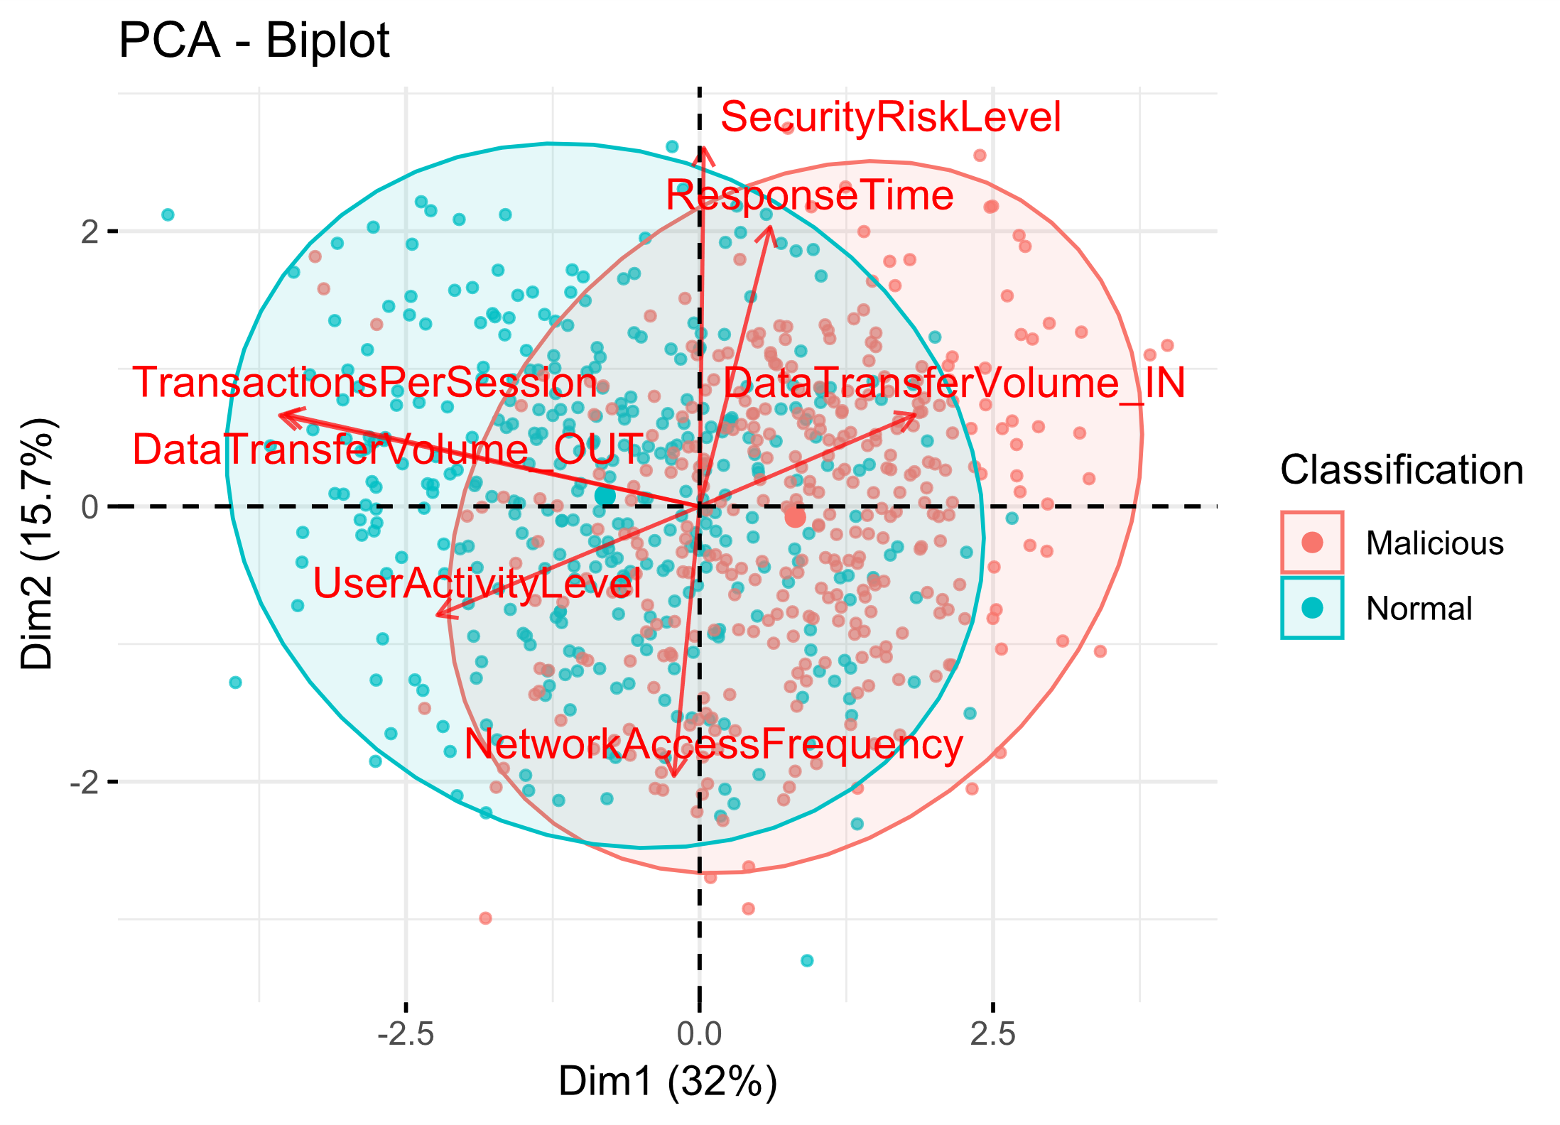
Figure 1: biplot for PC1 vs PC2

The PCA plot is little bit tricky to explain due to large number of overlapping samples. But the two clusters of classes, i.e., malicious and normal are clear. The two clusters are divided mainly alongside the first principal component, where most malicious events are on the positive side of the axis and most normal events are on the negative side of the axis.

DataTransferVolume_OUT, TransactionPerSession, and UserActivityLevel have negative and large loadings on PC1. This suggests that higher values of these features contribute negatively to the variation explained by PC1. DataTransferVolume_IN on the other hand has a positive and moderate loading on PC1 meaning it contributes positively to the variation explained by PC1. So, these are the variables that mostly help determine which of the events are malicious and which are normal.

SecurityRiskLevel, and ResponseTime have positive loadings on PC2, suggesting that higher values of these variables contribute positively to the variation explained by PC2. On the other hand, NetworkAccessFrequency has negative loading on PC2 denoting its negative contribution on PC2.

v. Ans
After analysing all the information of the results from parts (iii) to (iv) it can be conclude that, if I plot histogram for data visualization and observe Figure 2: histogram for PC1 the Normal and Malicious events can easily be classified and most of the length of the vectors are covered, but if we consider Figure 3: histogram for PC2, Normal and Malicious events cannot easily classified and most of the length of the vectors are not covered. Evidently, in the result PC1 axis has a greater contribution then PC2 axis.

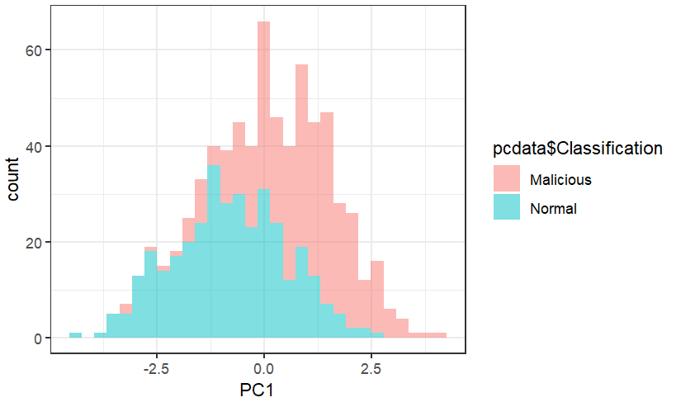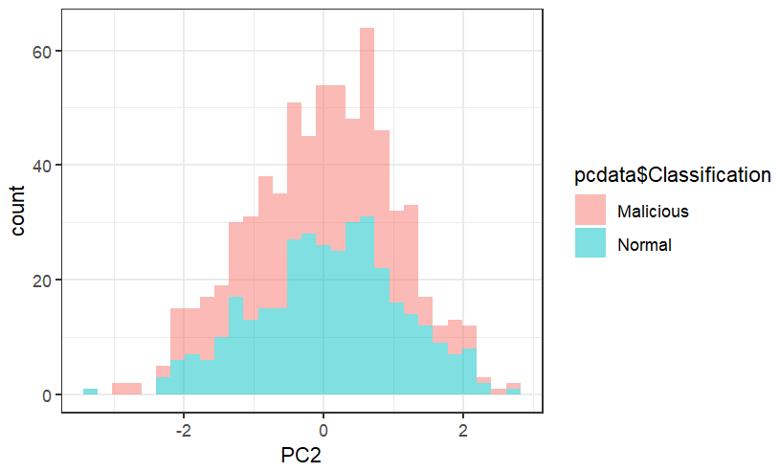
Figure 3: histogram for PC2

Figure 2: histogram for PC1

